QUESTION 1: Age & Gender Distribution of Donors

Yeh infographic asal mein yeh dikha rahi hai ke organ donate karne waale log kaun hain, unki umar (age) kya hai, aur mard (men) ya aurat (women) mein se kaun zyada donate kar raha hai.
Isko asaan alfaaz mein samajhte hain:

1. Kaun zyada donate kar raha hai? (Gender Distribution)
Neeche wala bar chart (blue aur orange columns) batata hai ke:
- Dono taqreeban barabar hain, lekin Aurton (Females) ki tadaad thodi si zyada hai.
- Females: 407 log (50.9%)
- Males: 393 log (49.1%)
2. Donors ki umar kya hai? (Overall Age Distribution)
Upar wala bada chart (blue bars) dikhata hai ke zyada tar donors ki umar 25 se 50 saal ke darmiyan hai.
- Sabse zyada donors 30 se 40 saal ki umar ke hain.
- Average (Mean) age 38 saal hai. Yani na bahut budhay hain aur na bahut chotay bachay.
3. Mard aur Aurat ki umar mein farq (Age Distribution by Gender)
Yahan ek dilchasp baat nazar aati hai (upar right side wala curve chart):
- Auratein (Orange line): Donating karne wali aurtein zyada tar jawan hain (unki peak 30 saal ke qareeb hai).
- Mard (Blue line): Donating karne waale mard thode bari umar ke hain (unki peak 42 saal ke qareeb hai).
- Table mein bhi yahi likha hai ke mardon ki average age (42.7) aurton ki average age (33.8) se zyada hai.

Yeh Analysis kyun ho raha hai?
Iska maqsad yeh samajhna hai ke:
- Targeting: Agar organ donation ki campaign chalani ho, toh humein pata hai ke mardon mein 40+ walon ko aur aurton mein 30+ wali category ko target karna chahiye.
- Gap Analysis: Hum dekh sakte hain ke 60 saal se upar ke log bahut kam hain, toh kya wahan koi health issue hai ya awareness ki kami?

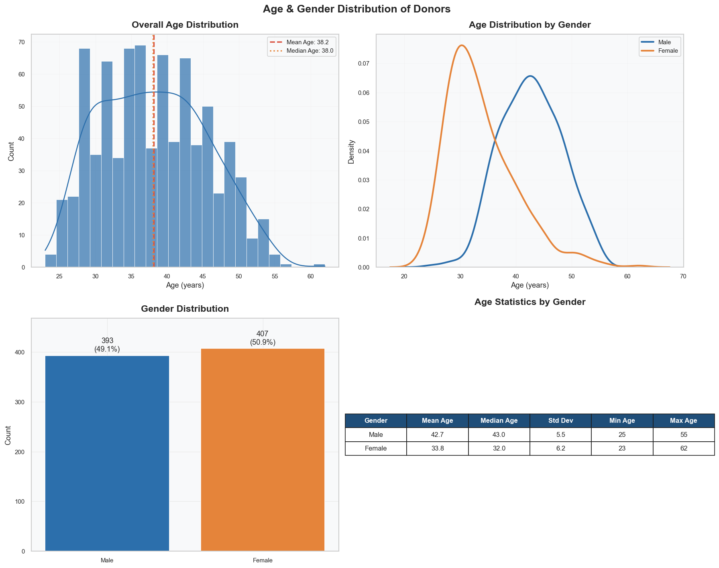

QUESTION 2: Blood Type Surplus vs. Shortage

Yeh infographic yeh dikha rahi hai ke hospital ya blood bank mein kis khoon (blood type) ki zaroorat zyada hai aur kaunsa blood hamare paas zyada miqdar mein maujood hai.
Iska asaan khulasa yeh hai:

1. Khoon ki zaroorat (Recipient Demand)
Upar left wala chart dikhata hai ke kin logon ko khoon ki sabse zyada zaroorat hai.
- O+ (15.8%) aur B- (15.2%) blood types ki sabse zyada demand hai.
- Baqi blood types ki demand taqreeban milti julti hai.
2. Khoon dene wale (Donor Availability)
Upar right wala chart dikhata hai ke hamare paas donor kitne hain.
- Sabse zyada donors O+ (37.0%) aur A+ (33.0%) ke hain.
- AB- aur B- dene wale log sabse kam hain (sirf 2.0%).
3. Muqabla: Zaroorat vs Maujoodgi (Comparison)
Neeche wale dono charts asal masla dikhate hain. Inhe dekh kar pata chalta hai ke:
- Fayde mein (Surplus): A+ aur O+ blood types hamare paas zaroorat se zyada hain. Inke bars green hain (upar ki taraf), jo dikhate hain ke +20% se zyada izafi khoon maujood hai.
- Nuqsan mein (Shortage): Baqi tamam blood types (A-, AB+, AB-, B+, B-, O-) ki kami hai. Inke bars red hain (neeche ki taraf).
- Sabse zyada kami B- blood type ki hai (-13.2%), yaani iski zaroorat bahut zyada hai lekin dene wale bahut kam hain.

Iska natija kya hai?
Yeh analysis humein batata hai ke blood bank ko apni tawajjo B-, AB-, aur A- jaise blood groups ke donors dhoondne par deni chahiye, kyunke inki shortage chal rahi hai.
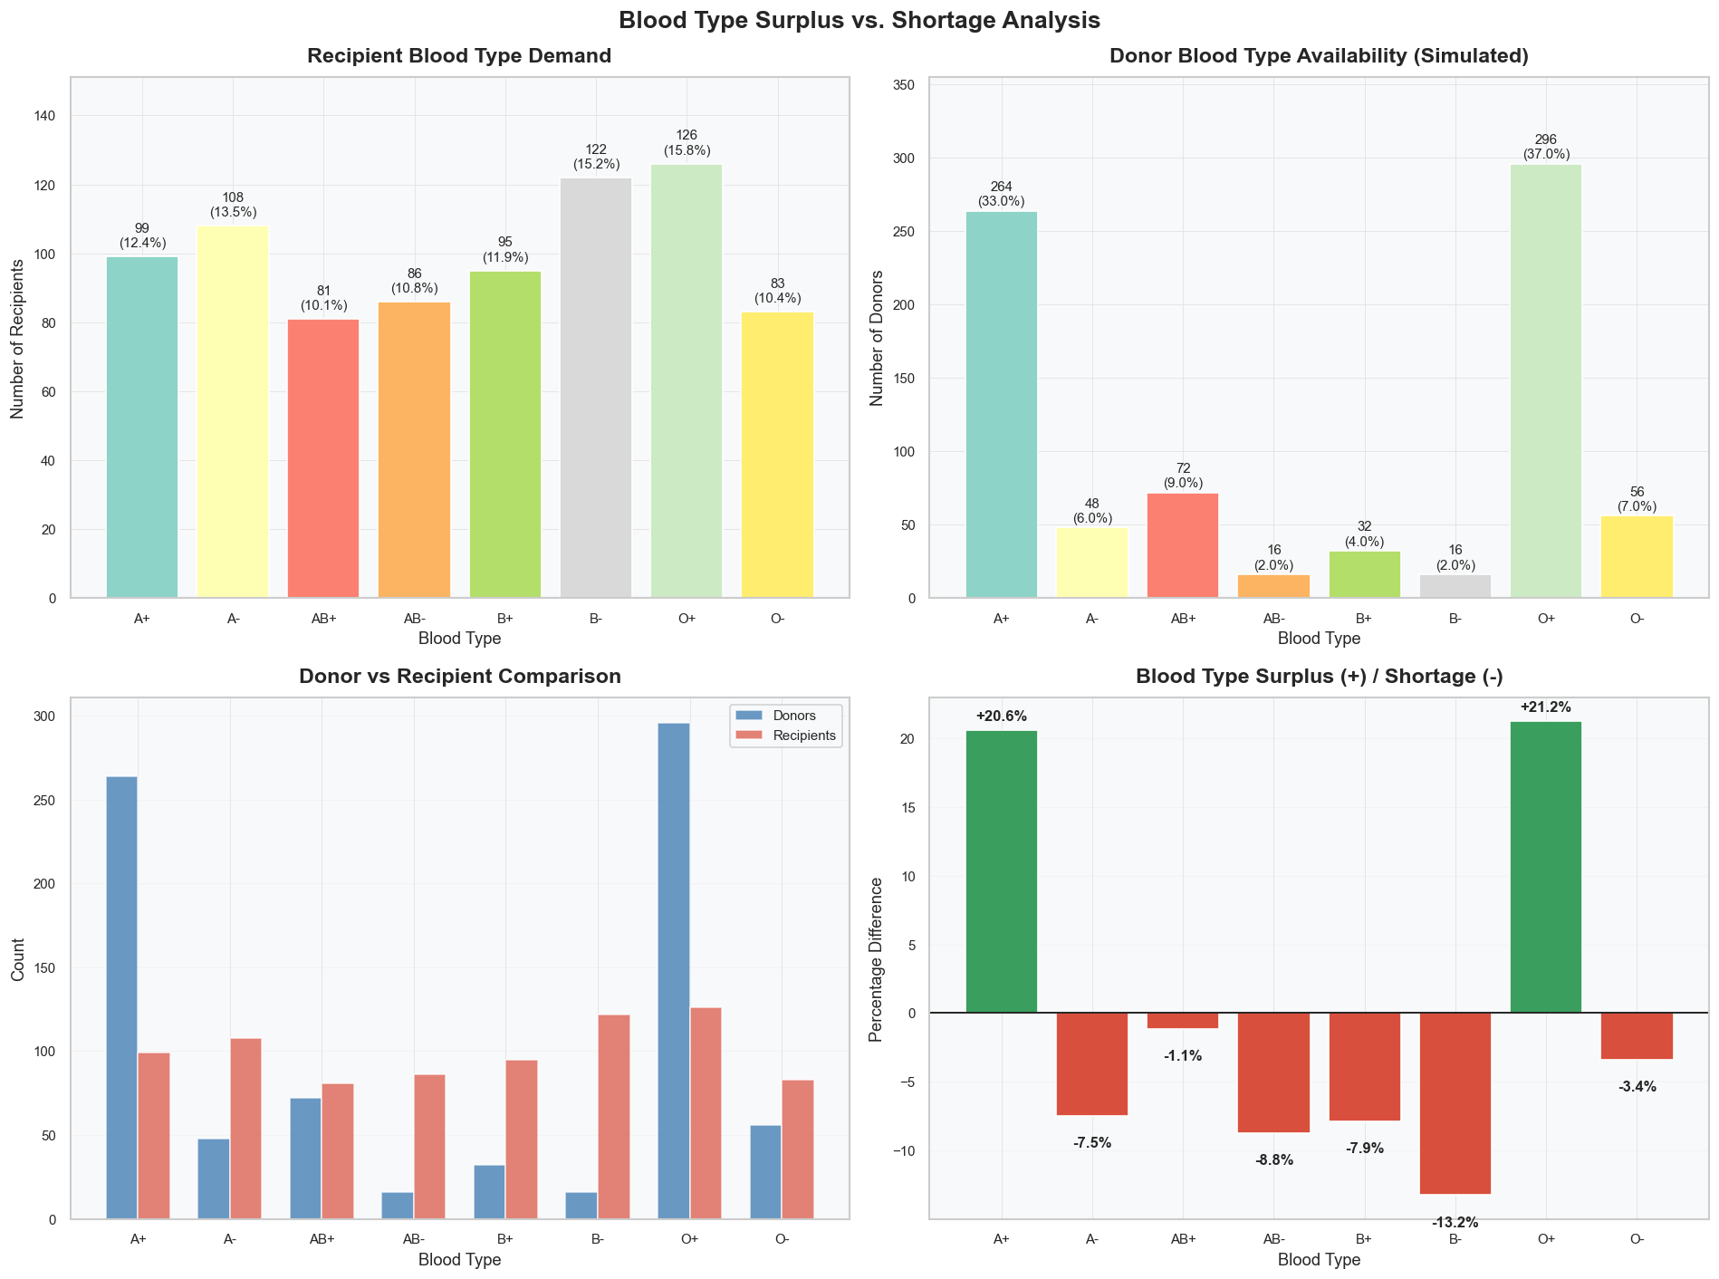

Question 3: Organ Supply-Demand Gap

Yeh infographic humein yeh samjha rahi hai ke kaunse insani aaza (organs) ki sabse zyada demand hai aur kitne log unhe donate karne ke liye maujood hain. Asaan alfaaz mein, yeh "Zaroorat aur Supply" ka muqabla hai.
Iska tafseeli khulasa yeh hai:

1. Kitne Mareez Intezar Mein Hain? (Organ Demand)
Upar left wala chart dikhata hai ke kin organs ki zaroorat sabse zyada hai:
- Kidney (18.8%): Sabse zyada log Kidney ke intezar mein hain (150 mareez).
- Heart (17.9%): Iske baad Dil ki bari aati hai.
- Baqi aaza jaise Cornea, Liver, aur Lungs ki demand taqreeban milti julti hai.
2. Kitne Donors Maujood Hain? (Organ Supply)
Upar right wala chart dikhata hai ke donors kin organs ko donate karne ke liye taiyar hain:
- Kidney (90.0%): Khushi ki baat yeh hai ke Kidney donate karne wale donors ki tadaad sabse zyada hai (450 donors).
- Pancreas (25.0%): Isko donate karne wale log sabse kam hain.
3. Asal Masla: Gap Analysis (Supply-Demand Gap)
Neeche wale charts (khas taur par green aur red bars wala) asal kahani batate hain:
- Zaroorat se zyada (Surplus): Jin organs ke liye green bars neeche ki taraf hain, unka matlab hai ke wahan donors ki tadaad mareezon se zyada hai. Maslan, Kidney ka gap -300 hai, yani hamare paas zaroorat se 300 zyada donors maujood hain. Cornea aur Liver mein bhi donors kafi zyada hain.
- KAMI (Shortage): Sirf Pancreas aisa organ hai jahan red bar upar ki taraf hai (+3). Iska matlab hai ke mareez zyada hain aur donors kam, is liye wahan shortage hai.
- Heart mein gap bahut kam hai (-7), yani wahan supply aur demand taqreeban barabar hai.

Iska Natija (Conclusion):
Is analysis se pata chalta hai ke:
- Hamari Kidney, Cornea, aur Liver ki donation campaigns bahut kamyab rahi hain kyunke wahan donors ki tadad kafi behtar hai.
- Humein Pancreas aur Heart donation par mazeed tawajjo dene ki zaroorat hai taake wahan mareezon ka intezar khatam kiya ja sake.
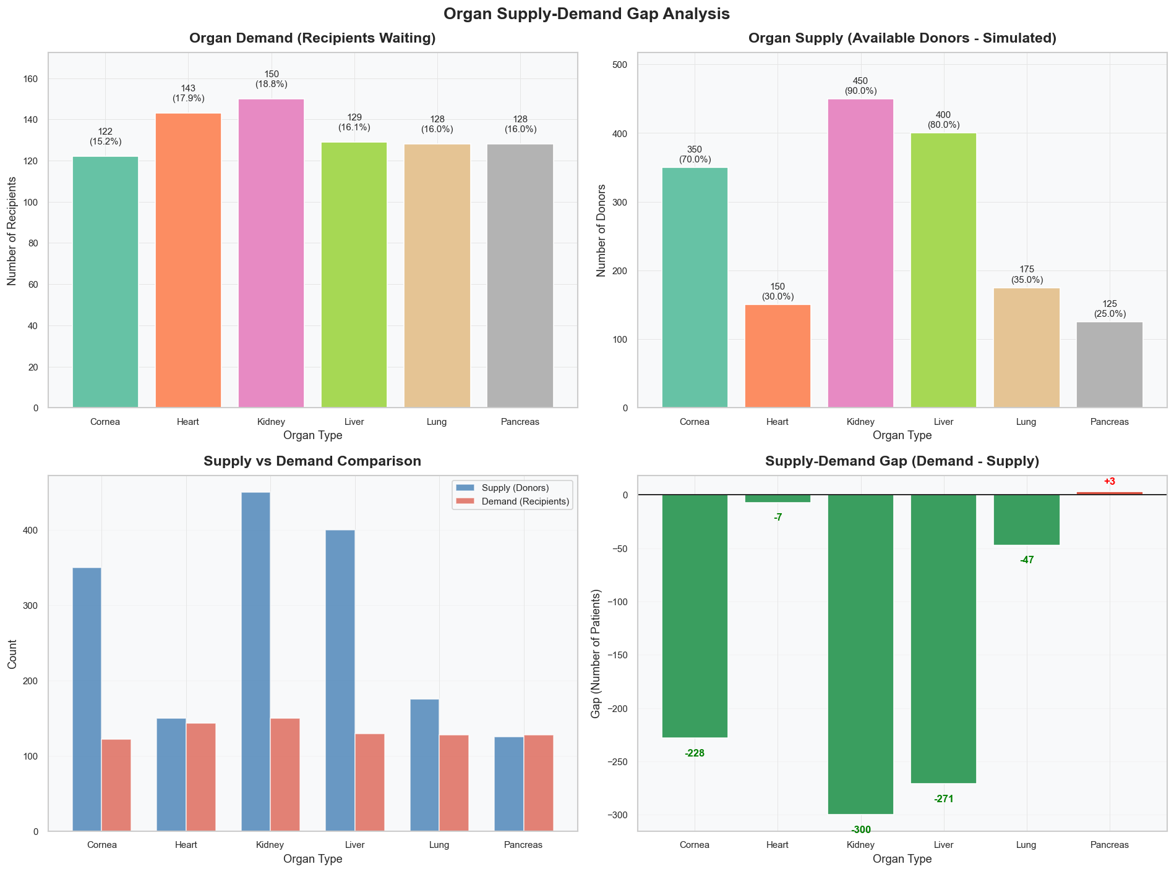

Question 4: How Quickly Are Organs Harvested After Death?
Yeh aakhri analysis sabse ahem hai kyunke organ transplant mein waqt hi sabse badi rukawat hota hai. Isay "Harvest Time" kehte hain—yani maut ke baad kitni jaldi organ ko jism se nikal kar mehfooz kar liya gaya.
Iska asaan khulasa yeh hai:

1. Average Kitna Waqt Lag Raha Hai? (Distribution of Harvest Times)
Pehle do charts (Histogram aur Boxplot) batate hain ke:
- Zyada tar organs maut ke 8 se 16 ghanton ke darmiyan nikaal liye jaate hain.
- Average (Mean) aur Median waqt 12.0 ghante hai.
- Is data mein koi "Outliers" nahi hain (0.0%), yani koi bhi case had se zyada late nahi hua.
2. Hafte ke Din aur Mahine (Time by Day & Month)
In charts se humein pata chalta hai ke:
- Tuesday (Mangal) ke din kaam thoda jaldi hota hai (median waqt 11 ghante hai).
- Baqi tamam dinon aur Jan se April ke mahino mein kaam ki raftaar taqreeban ek jaisi (11-12 ghante) rehti hai.
3. Organ ke Hisab se Waqt (Harvest Time by Organ Type)
Har organ ki apni sensitivity hoti hai:
- Kidney aur Liver: Inka median harvest time thoda zyada (13 ghante) hai.
- Cornea, Lung aur Pancreas: Inhe thoda jaldi (11 ghante) harvest kar liya jata hai.
4. Sabse Khatarnak Baat: Critical Thresholds
Aakhri chart (red bars) dikhata hai ke kitne cases "Safe limit" se bahar ja rahe hain:
- 100% cases mein 6 ghante se zyada waqt lag raha hai.
- 44.1% cases aise hain jin mein 12 ghante se bhi zyada waqt lag gaya.
- Achi baat yeh hai ke koi bhi case 24 ghante se upar nahi gaya (0.0%).

Iska Natija (Summary):
Humein koshish karni chahiye ke harvest time ko mazeed kam kiya jaye, kyunke jitni dair hogi, organ ki transplant ke liye kamyabi ke chances utne hi kam ho sakte hain.
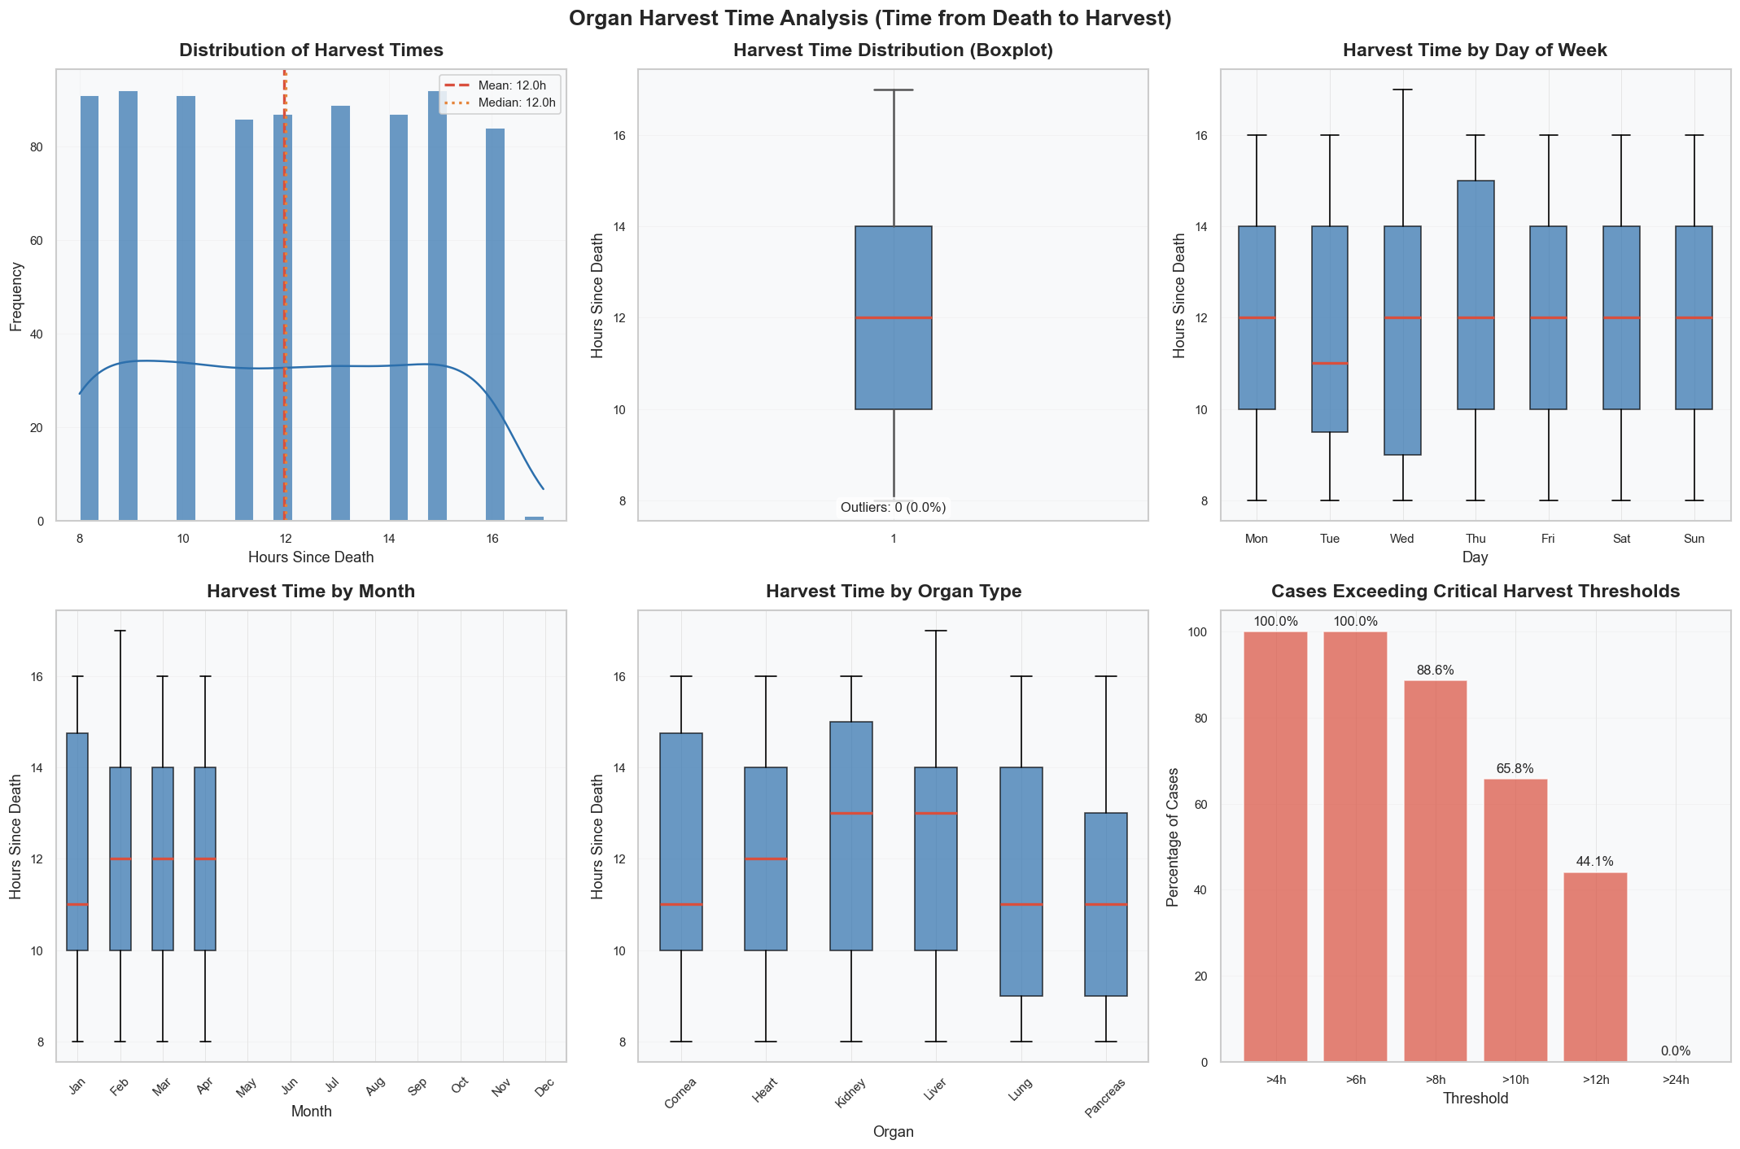

Question 5: Medical Conditions Affecting Donor Eligibility
Yeh aakhri infographic humein yeh batati hai ke kitne log donor banne ke liye fit hain aur kaunsi bimarigan (medical conditions) unki raste mein rukawat ban sakti hain. Iska maqsad organ ki quality aur "usable yield" (yani kitne organs asal mein istemal ho sakti hain) ka andaza lagana hai.
Iska asaan khulasa yeh hai:

1. Kaunsi Bimariyan Zyada Hain? (Prevalence)
Upar left wala chart dikhata hai ke potential donors mein sabse aam masle kya hain:
- Diabetes (20.8%): Sabse zyada donors iska shikar hain.
- Heart Disease aur Liver Disease: Yeh dono bhi kafi zyada hain (taqreeban 16-17%).
- Kidney Disease (7.2%): Yeh sabse kam hai.
2. Bimari Kitni Sanjeeda Hai? (Severity & Impact)
Upar right wala chart (Red aur Green bars) dikhata hai ke kaunsi bimari donor banne ke liye kitni khatarnak hai (10 ka matlab hai "sabse zyada sakht restriction"):
- Heart aur Kidney Disease (Score: 9): Agar kisi ko yeh masle hain, toh unka organ donate karna bahut mushkil hai.
- Asthma (Score: 3): Yeh ek "light" condition hai, iske bawajood log donate kar sakte hain.
3. Ek Se Zyada Bimariyan (Number of Conditions per Donor)
Neeche left wala chart batata hai ke:
- 77.9% (623 log) aise hain jinhe sirf ek medical condition hai.
- 16.2% aise hain jinhe koi bimari nahi hai (High Eligibility).
- Sirf 5.9% log aise hain jinhe do ya zyada masle hain.
4. Kitne Log Fit Hain? (Donor Eligibility Estimate)
Pie chart asal natija dikhata hai:
- Medium Eligibility (83.8%): Zyada tar donors "theek thaak" hain, yani unhe 1-2 masle hain lekin woh phir bhi donate kar sakte hain agar sahi screening ho.
- High Eligibility (16.2%): Yeh woh log hain jo bilkul sehat-mand hain aur behtareen donors hain.

Iska Natija (Conclusion):
Zyada tar donors (83.8%) ke paas koi na koi medical condition hai (jaise Diabetes ya Hypertension), isliye screening team ko bahut dhyan se dekhna padta hai ke kaunsa organ behtar kaam karega. Diabetes aur Heart Disease hamare donors ke liye sabse bade challenges hain.
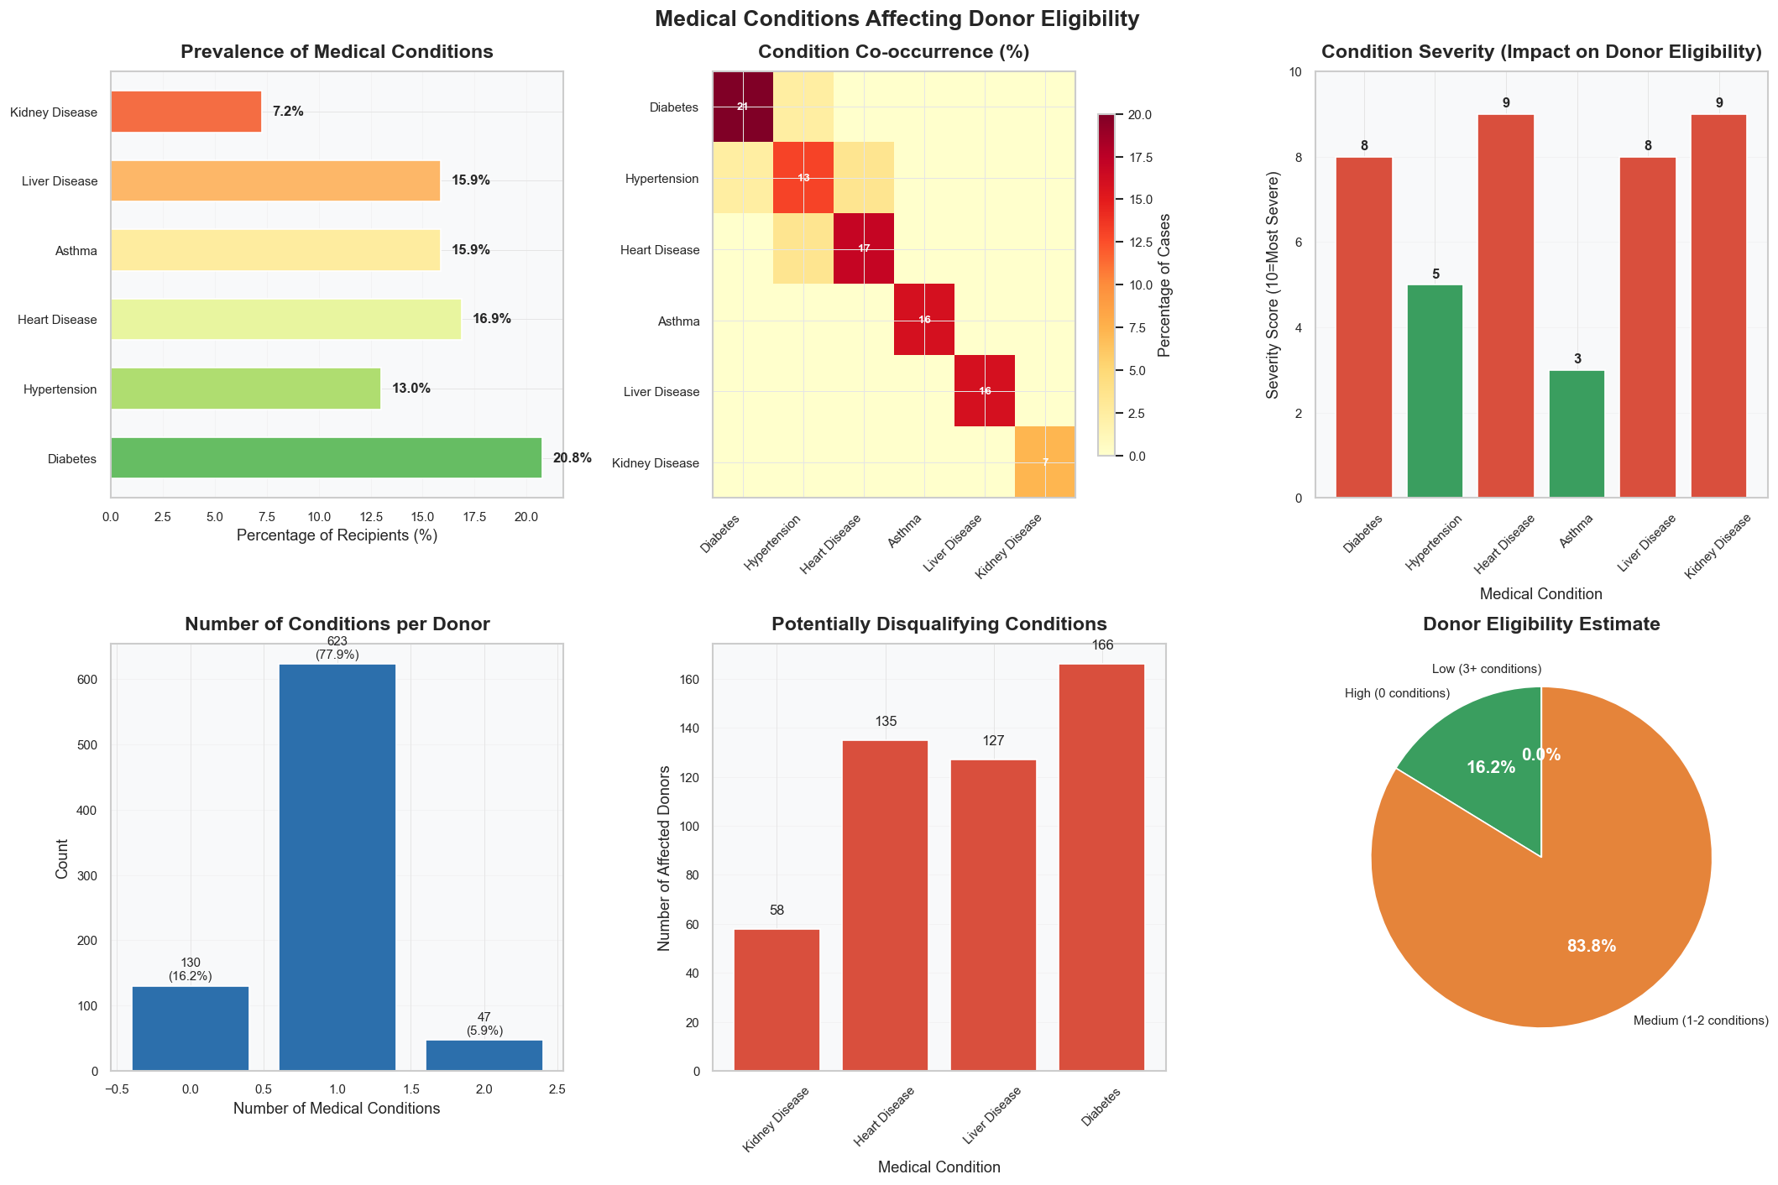

Question 6: Primary Causes of Death Among Deceased Donors
Yeh infographic batati hai ke jo log donate karte hain, unki maut ki asal wajah (Cause of Death) kya hai. Isay samajhna is liye zaroori hai kyunke maut ki wajah batati hai ke donor ke organs kitne healthy ya usable hain.
Iska asaan khulasa yeh hai:

1. Maut ki Sabse Badi Wajohaat (Distribution of Causes)
Pehle do charts (Bar aur Pie chart) dikhate hain ke donors ki maut ki sabse aam wajah kya rahi:
- Cardiovascular (28.8%): Sabse zyada donors dil ke masail (heart issues) ki wajah se fote hue.
- Cerebrovascular (15.0%): Doosri badi wajah brain stroke ya dimaagh ki ragon ka phatna hai.
- Trauma (11.9%): Accidents aur hadsaat ki wajah se hone wali maut.
2. Umar ke Hisab se Maut ki Wajah (Cause by Age Group)
Neeche wala left chart dikhata hai ke umar ke sath maut ki wajah kaise badalti hai:
- Jawan Donors (<30 saal): In mein Trauma (yellow bar) aur Respiratory (light green) masail zyada hain.
- Badi Umar ke Donors (56-65 saal): In mein Cardiovascular (teal bar) yani dil ki bimariyon se maut ka taanasub 50% tak chala jata hai.
3. Organ aur Maut ka Taaluq (Cause of Death by Organ Type)
Neeche wala right chart batata hai ke kis organ ke donor ki maut ki wajah kya thi:
- Tamam organs (Cornea, Heart, Kidney, etc.) ke donors mein Cardiovascular wajah sabse common hai.
- Trauma ke cases Kidney aur Liver donors mein kaafi nazar aate hain, kyunke hadsay mein aksar baaqi organs sahi salamat bach jaate hain.

Iska Faida Kya Hai? (Importance)
- Organ Health: Agar maut Trauma se ho, toh organs aksar jawan aur zyada healthy hote hain.
- Risk Assessment: Agar maut Infection ya Malignancy (Cancer) se ho, toh doctors ko bohot ehtiyat karni parti hai taake mareez ko bimari na lage.
- Future Strategy: Is data se hospitals ko andaza hota hai ke unhein kis tarah ke donors par zyada focus karna chahiye.
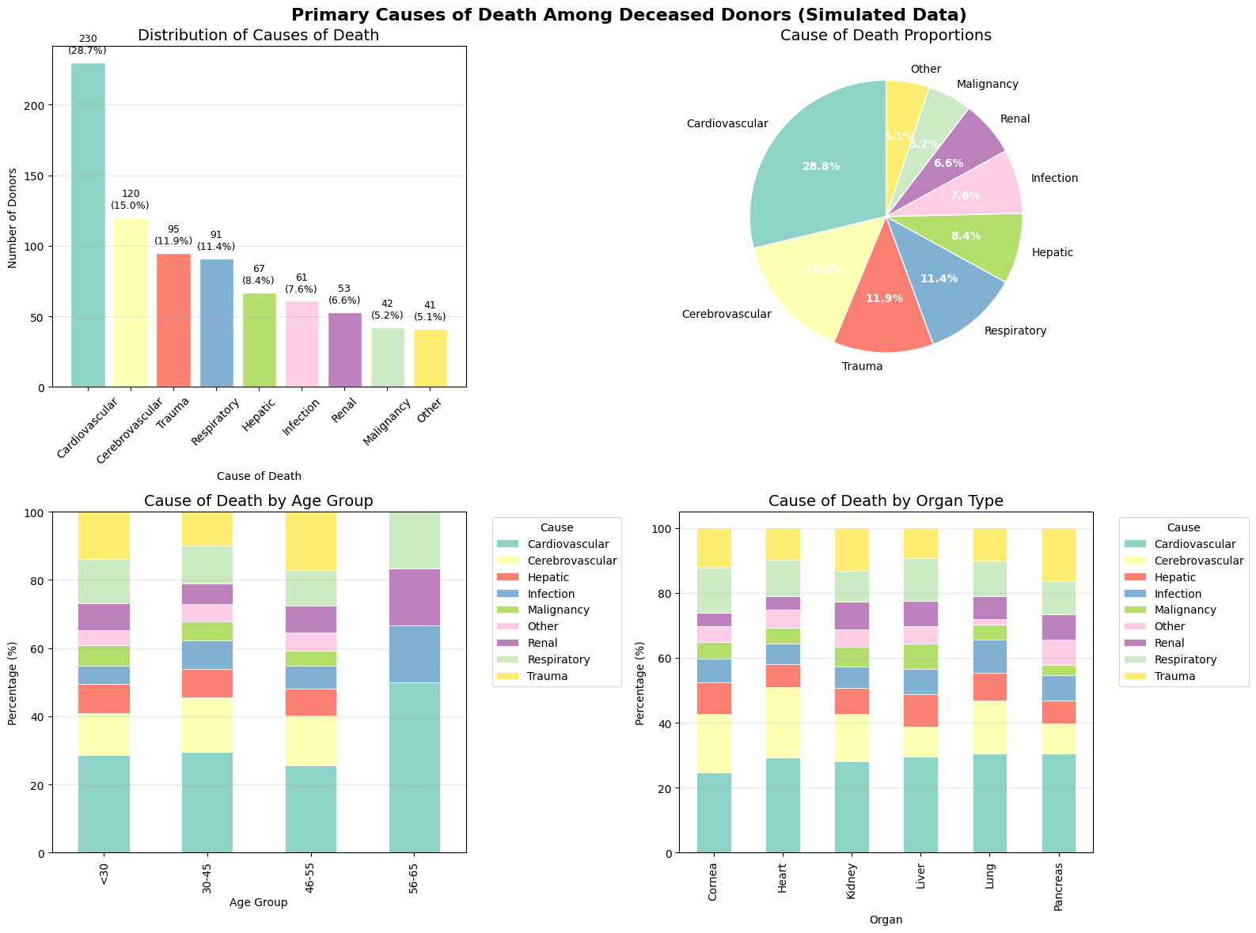

Question 7: Hepatitis Risk Proportion

Yeh analysis humein donors mein Hepatitis (jigar ki sozish) ke khatray aur iske asaraat ke baare mein batata hai. Organ transplant mein yeh bohot ahem hai kyunke Hepatitis ki wajah se donor ki eligibility aur organ ki safety par bada asar padta hai.
Iska asaan khulasa yeh hai:

1. Kitne Donors Hepatitis Positive Hain? (Overall Status)
Pehla chart batata hai ke:
- 74.1% (593 log) Hepatitis Negative hain, yani woh is lihaaz se bilkul safe donors hain.
- 25.9% (207 log) Hepatitis Positive hain, jin ke organs istemal karne ke liye khas ehtiyat aur screening ki zaroorat hoti hai.
2. Umar aur Gender ka Farq (Prevalence by Age & Gender)
- Sabse zyada khatra: 60 saal se upar ki umar ke donors mein Hepatitis ka tanasub 100% hai, jabke 30-40 saal walon mein yeh 29.6% hai.
- Gender: Aurton (Females) mein Hepatitis ka rate (28.0%) mardon (23.7%) ke muqable mein thoda zyada dekha gaya hai.
3. Jigar ki Bimariyon se Taaluq (Liver Conditions)
Hepatitis ka sabse zyada asar jigar par hota hai:
- Jin donors ko pehle se Liver Disease ya jigar ke masail hain, un mein Hepatitis ka rate 88% se 90% tak hai. Iska matlab hai ke jigar ki bimari aur Hepatitis aksar ek saath hote hain.
4. Organ Needed: Kis Organ par kitna asar hai?
Neeche wala aakhri chart dikhata hai ke:
- Liver (88.4%) aur Kidney (44.0%) ke mareezon ko milne wale donors mein Hepatitis ka khatra zyada hai.
- Heart aur Lung ke donors mein Hepatitis ka rate 0.0% hai, yani yeh organs bilkul pak-saaf hain.

Yeh Analysis Kyun Zaroori Hai? (Importance)
- Transplant Safety: Doctors ko yeh faisla karne mein madad milti hai ke kya Hepatitis positive donor ka organ kisi aise mareez ko diya ja sakta hai jise pehle se Hepatitis ho.
- Risk Management: Hepatitis positive organs ko mardood (reject) karne ki bajaye unhein "High Risk" category mein rakh kar sahi mareez ke liye bachaya ja sakta hai.

Question 8: Geographic Distribution Across 19 Cities
Yeh infographic humein yeh samjhati hai ke organ donation aur recipients (jinhein organs ki zaroorat hai) poore mulk ke 19 shehron (cities) mein kis tarah phele hue hain. Iska maqsad yeh dekhna hai ke kin ilaqon mein donation zyada ho rahi hai aur kahan mazeed kaam karne ki zaroorat hai.
Iska asaan khulasa yeh hai:

1. Shehron mein Recipients ki Tadaad (Distribution by City)
Upar left wala chart dikhata hai ke kin shehron mein sabse zyada mareez intezar kar rahe hain:
- Islamabad, Karachi, aur Lahore (7.1% each): In bade shehron mein mareezon ki tadaad sabse zyada (har shehr mein 57 log) hai.
- Quetta (1.1%): Yahan sabse kam mareez record kiye gaye hain (sirf 9 log).
- Baqi shehr jaise Faisalabad (6.6%) aur Multan (6.1%) bhi kafi ahem hain.
2. Bade vs Chote Shehr (Top 5 vs Bottom 5)
Upar right wala chart comparison dikhata hai:
- Top 5 shehron mein mareezon ki tadaad nichle 5 shehron ke muqable mein double se bhi zyada hai.
- Is se pata chalta hai ke bade shehron ke hospitals par bohot zyada bojh (load) hai.
3. Geographic Inequality (Lorenz Curve)
Neeche right wala chart (Gini Coefficient) yeh batata hai ke distribution kitni barabar (equal) hai:
- Gini Coefficient (0.192): Yeh score batata hai ke distribution kafi had tak theek aur barabar hai, yani mareez sirf kisi ek shehr mein jama nahi hain balkay poore mulk mein phele hue hain.

Iska Faida Kya Hai? (Importance)
- Allocation Network: Is data se andaza hota hai ke organs ko ek shehr se dusre shehr bhejne ke liye behtareen raasta (logistics) kya hona chahiye.
- Recruitment Efforts: Jin shehron mein donation kam hai (jaise Quetta ya Sahiwal), wahan awareness campaigns chalane ki zaroorat hai.
- Regional Access: Is se yeh ensure kiya ja sakta hai ke door-daraz ke shehron ke mareezon ko bhi barabar ka haq mile.
